Shrinkage correlation: NZDUSD and EURGBP
Method 08 / eight-major panel / delta = 0.2 and Ledoit-Wolf / Alpari D1 full available history

Study setup
Logical pair: NZDUSD , EURGBP
Broker symbols: NZDUSD_i , EURGBP_i
Snapshot: 2026-11-03_majors_alpari_D1
Timeframe: D1
Common eight-major panel window: 1999-01-06 to 2026-11-02 (UTC bar dates)
Panel matched return count n: 7127
Dropped unfinished last bar dated 2026-11-03 UTC after a tick-volume check against the prior complete day.
Fixed shrinkage: delta=0.2, mu=3.9170889e-05 (mean of diag(S))
Ledoit-Wolf estimated delta: 0.0042157642
Panel symbols: EURUSD, GBPUSD, AUDUSD, NZDUSD, USDJPY, USDCHF, USDCAD, EURGBP
Complete matched rows (Excel): NZDUSD-EURGBP_Shrinkage_D1.xlsx
Complete matched rows (HTML table): NZDUSD-EURGBP_Shrinkage_D1_data.html

Method carried forward
Shrinkage blends the sample covariance matrix S of matched daily log returns of close, ln(close_t / close_t-1), toward a simple target, then converts the shrunk covariance into correlations. Quotes are not inverted. This experiment builds one common calendar across all eight majors, forms S with the unbiased n-1 divisor, then reports two shrinkage specs: fixed delta = 0.2 with mu equal to the average sample variance (mu * I target), and sklearn Ledoit-Wolf with its estimated delta. Pair reports pull rho_ij from those panel matrices. Same-panel Pearson r is a side check only. Shrinkage improves conditioning; it is not a cause, not a lead, and not a trading signal.

Results
pearson_r | rho_02 | rho_LW | rho_02_minus_r | rho_LW_minus_r | delta_LW
0.035833 | 0.027906 | 0.035658 | -0.007927 | -0.000175 | 0.00421576

Conclusion
Over the common 7127-day eight-major panel for NZDUSD and EURGBP (broker quote directions unchanged), fixed-delta shrinkage correlation at delta=0.2 is 0.0279 (positive, weak linear link in this sample). Ledoit-Wolf rho is 0.0357 with estimated delta=0.004216. Same-panel Pearson r is 0.0358 (rho_02 minus r = -0.0079; rho_LW minus r = -0.0002). This does not establish cause, lead-lag, or a lasting trading rule.

Charts
Daily closes
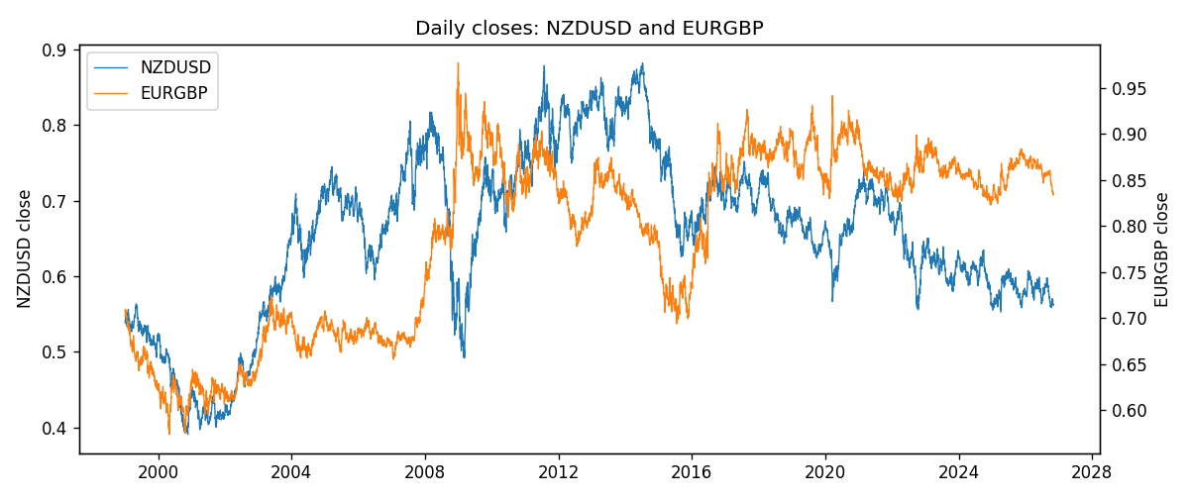
Daily log returns
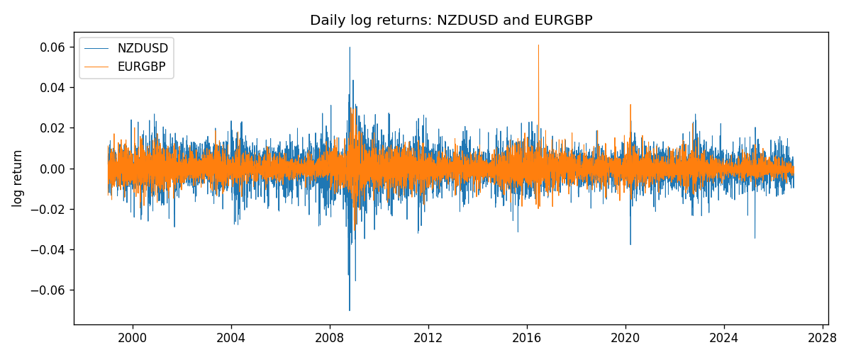
Log-return scatter
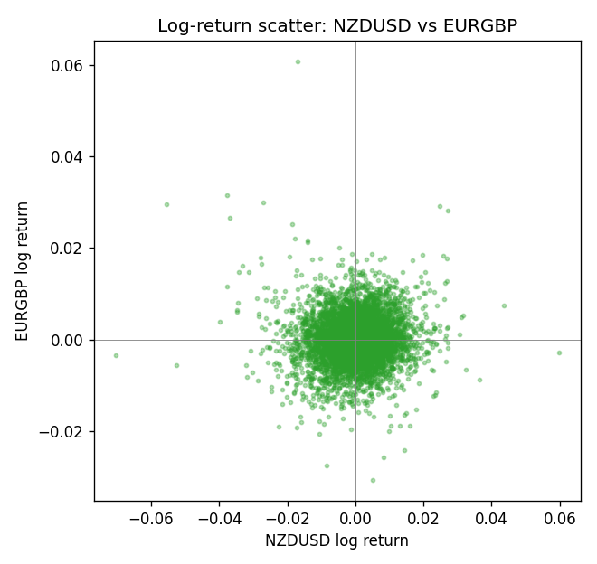

Data report
Every panel row for this pair slice is stored in the sibling Excel workbook named NZDUSD-EURGBP_Shrinkage_D1.xlsx. Full-panel covariance and correlation matrices are saved once under outputs/ as CSV files. Embedding all rows as a Word table is impractical at this length; the Word file holds the column list, column summaries, and the first and last 15 matched rows.
Columns: time, NZDUSD_open, NZDUSD_high, NZDUSD_low, NZDUSD_close, NZDUSD_tick_volume, NZDUSD_spread, NZDUSD_real_volume, NZDUSD_log_return, EURGBP_open, EURGBP_high, EURGBP_low, EURGBP_close, EURGBP_tick_volume, EURGBP_spread, EURGBP_real_volume, EURGBP_log_return
Column summaries (panel rows)
column | count | mean | std | min | 25% | 50% | 75% | max
NZDUSD_open | 7127 | 0.65707489 | 0.10792246 | 0.3913 | 0.59224 | 0.66889 | 0.725215 | 0.88218
NZDUSD_high | 7127 | 0.66100044 | 0.10841069 | 0.3961 | 0.595625 | 0.6726 | 0.72964 | 0.88421
NZDUSD_low | 7127 | 0.65338952 | 0.10751648 | 0.3897 | 0.588615 | 0.6651 | 0.721335 | 0.87988
NZDUSD_close | 7127 | 0.65715675 | 0.10791625 | 0.3907 | 0.5923 | 0.66906 | 0.725335 | 0.8822
NZDUSD_tick_volume | 7127 | 69244.396 | 123501.01 | 17 | 5842 | 34224 | 58735 | 1127682
NZDUSD_spread | 7127 | 30.023572 | 25.540824 | 0 | 9 | 17 | 40 | 80
NZDUSD_real_volume | 7127 | 1.6834718e+10 | 8.5315436e+10 | 0 | 0 | 0 | 0 | 2.705649e+12
NZDUSD_log_return | 7127 | 2.447e-05 | 0.00764665 | -0.07027433 | -0.00423198 | 0.00024001 | 0.00459119 | 0.05966839
EURGBP_open | 7127 | 0.78791082 | 0.09637243 | 0.5734 | 0.6884 | 0.83449 | 0.8655 | 0.9769
EURGBP_high | 7127 | 0.79099288 | 0.09674788 | 0.5789 | 0.6906 | 0.83742 | 0.868415 | 0.9799
EURGBP_low | 7127 | 0.78520819 | 0.09619038 | 0.5682 | 0.6864 | 0.83222 | 0.86303 | 0.9661
EURGBP_close | 7127 | 0.7879552 | 0.09637142 | 0.5735 | 0.6884 | 0.83458 | 0.86556 | 0.977
EURGBP_tick_volume | 7127 | 87771.585 | 145890.89 | 332 | 6734 | 44866 | 82002 | 1424684
EURGBP_spread | 7127 | 21.129928 | 19.050945 | 0 | 4 | 13 | 40 | 50
EURGBP_real_volume | 7127 | 2.8086114e+10 | 1.3572254e+11 | 0 | 0 | 0 | 0 | 3.5726265e+12
EURGBP_log_return | 7127 | 2.379e-05 | 0.00487339 | -0.03067367 | -0.00262314 | -9.978e-05 | 0.00256668 | 0.06075387
First 15 panel rows (selected columns)
time | NZDUSD_close | EURGBP_close | NZDUSD_log_return | EURGBP_log_return
1999-01-06 | 0.5383 | 0.7019 | 0.0020455609 | -0.013303338
1999-01-07 | 0.5417 | 0.7097 | 0.0062963171 | 0.011051402
1999-01-08 | 0.5414 | 0.7062 | -0.00055396548 | -0.004943862
1999-01-11 | 0.547 | 0.7053 | 0.010290425 | -0.0012752393
1999-01-12 | 0.5441 | 0.7077 | -0.0053157489 | 0.0033970309
1999-01-13 | 0.5387 | 0.708 | -0.0099742238 | 0.00042381861
1999-01-14 | 0.5386 | 0.7066 | -0.00018564931 | -0.0019793588
1999-01-15 | 0.5382 | 0.7012 | -0.00074294208 | -0.0076715819
1999-01-18 | 0.5372 | 0.7017 | -0.0018597736 | 0.00071280921
1999-01-19 | 0.5382 | 0.7007 | 0.0018597736 | -0.0014261269
1999-01-20 | 0.5404 | 0.7021 | 0.0040793678 | 0.0019960086
1999-01-21 | 0.5426 | 0.7016 | 0.0040627941 | -0.00071240297
1999-01-22 | 0.5361 | 0.7004 | -0.012051689 | -0.0017118406
1999-01-25 | 0.5342 | 0.6966 | -0.0035504102 | -0.0054402425
1999-01-26 | 0.5381 | 0.6962 | 0.0072741158 | -0.00057438255
Last 15 panel rows (selected columns)
time | NZDUSD_close | EURGBP_close | NZDUSD_log_return | EURGBP_log_return
2026-10-13 | 0.56127 | 0.84458 | 0.0047326165 | 0.00020130374
2026-10-14 | 0.55918 | 0.84553 | -0.0037306483 | 0.0011241873
2026-10-15 | 0.56185 | 0.84479 | 0.0047634855 | -0.00087557391
2026-10-16 | 0.56509 | 0.84307 | 0.0057501001 | -0.0020380844
2026-10-19 | 0.56616 | 0.84259 | 0.0018917133 | -0.00056950988
2026-10-20 | 0.56827 | 0.83957 | 0.0037199341 | -0.0035906254
2026-10-21 | 0.57003 | 0.83839 | 0.0030923331 | -0.00140647
2026-10-22 | 0.56815 | 0.83682 | -0.0033035227 | -0.0018743924
2026-10-23 | 0.56991 | 0.83751 | 0.0030929853 | 0.00082421033
2026-10-26 | 0.56826 | 0.83762 | -0.0028993932 | 0.00013133309
2026-10-27 | 0.56811 | 0.83595 | -0.00026399852 | -0.0019957343
2026-10-28 | 0.56261 | 0.83651 | -0.0097283914 | 0.00066967224
2026-10-29 | 0.56296 | 0.83553 | 0.00062190714 | -0.0011722209
2026-10-30 | 0.56307 | 0.83351 | 0.00019537668 | -0.0024205543
2026-11-02 | 0.56161 | 0.83426 | -0.0025962955 | 0.00089940465

